LIFEGUARD STAFFING PLAN

Table of Contents
SECTION 1: LIST OF AQUATIC VENUES 1
A. Pool A (PR00#####) 1
B. Pool B (PR00#####) 1
SECTION 2: OPERATIONS 1
A. Hours of Operation 1
B. Number of Lifeguards on duty 1
SECTION 3: ZONING DIAGRAM 1
A. Diagram for Pool A 1
B. Diagram for Pool B 1
SECTION 4: ROTATIONS 2
A. Rotation Schedule for Pool A 2
B. Rotation Schedule for Pool B 2
C. Definition of on duty lifeguards 2
D. Lifeguard supervision protocol 2
E. Rotation procedures 2
SECTION 5: OTHER POLICIES 2
A. Safety equipment requirement 2
B. Lifeguard Qualifications 2
C. Other requirements 2

SECTION 1: LIST OF AQUATIC VENUES

Pool A (PR00#####)
- Surface Area:
- Theoretical peak occupancy:

Pool B (PR00#####)
- Surface Area:
- Theoretical peak occupancy:

SECTION 2: OPERATIONS

Hours of Operation
- Pool A Hours AM to PM
- Pool B Hours AM to PM

Number of Lifeguards on duty
- Pool A active/on-duty lifeguards:
- Pool B active/on-duty lifeguards

SECTION 3: ZONING DIAGRAM

Diagram for Pool A

Diagram for Pool B

See requirements in AFR 2018 4-303.3; 4-303.2

EXAMPLE:
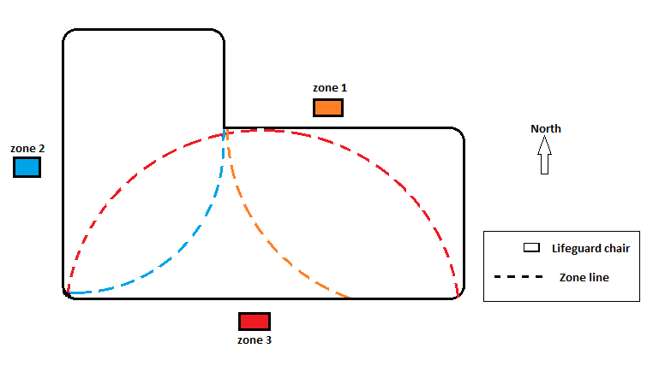

SECTION 4: ROTATIONS

Rotation Schedule for Pool A

Rotation Schedule for Pool B

EXAMPLE:

X= breaks
1-4 = Zones/location

Lifeguards |  | 8:00 AM | 8:30AM | 9:00 AM | 9:30 AM | 10:00 AM | 10:30 AM | 11:00 AM | 11:30 AM | 12:00 PM | 12:30 PM | 1:00 PM | 1:30 PM | 2:00 PM | 2:30 PM | 3:00 PM | 3:30 PM
8:00-4:00 | LG 1 | 1 | 4 | 3 | 2 | 1 | 4 | x | x | x | 2 | 1 | 2 | 3 | 4 | 1 | 2
8:00-4:00 | LG 2 | 2 | 1 | 4 | 3 | 2 | 1 | x | x | x | 3 | 2 | 3 | 4 | 1 | 2 | 3
8:00-4:00 | LG 3 | 3 | 2 | 1 | 4 | 3 | 2 | x | x | x | 4 | 3 | 4 | 1 | 2 | 3 | 4
8:00-4:00 | LG 4 | 4 | 3 | 2 | 1 | 4 | 3 | x | x | x | 1 | 4 | 1 | 2 | 3 | 4 | 1

Definition of on duty lifeguards

Lifeguard supervision protocol
See requirements in AFR 2018 4-303.4; 4-304.3

Rotation procedures
See requirements in AFR 2018 4-303.3

SECTION 5: OTHER POLICIES

Safety equipment requirement
See requirements in AFR 2018, 3-603.2; 3-603.7

Lifeguard Qualifications
See requirements in AFR 2018, 4-201.1; 4-201.2; 4-201.3

Other requirements
See requirements in AFR 2018, 3-603.8 (E) 2

